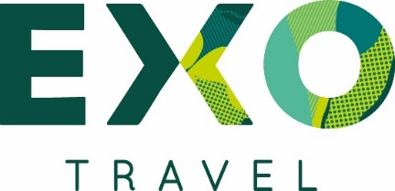

MEET THE FAMILY!

EXO Travel Indonesia is looking for French Speaking Travel Consultant to help handle our expanding business.
Working with an experienced team, you will be in daily contact with our clients and sales offices, processing bookings, answering questions and creating travel itineraries. We have clients from all over the world, however we specialize in European, US and Australian markets.
Successful candidates will have bright minds and be keen to learn about an exciting and rewarding segment of the travel industry.
Responsibilities:
- Correspond with overseas travel agents and partners of the company and provide them accurate, up-to-date and correct travel information
- Advise, create outlines and Travel itineraries for Tour operators/ Travel agents
- Make quotations/proposals and reconfirm bookings with/for overseas agents and ensure all services you entered are always updated in the system
- Make reservations with local suppliers and hotels if needed
- Understand about the existing and new products being offered by the company to be better able to fit the client requirements
- Work with the Operations team to deliver optimal service to clients on the ground
- Issue invoices in due time and assist accounting department with regard to payment
- Ensure all sales are reported in system software for your sales report
- Ensure EXO standards and Inbound processes are followed
- Look to improve handling time and productivity by making suggestions on how to simplify or speed up work processes
- Strive to achieve a high ratio of conversions versus enquiries

Apply now! Send your CV to dhanty@exotravel.com and get ready, this positions are available for Bali & Jogja office and INDONESIAN PASSPORT HOLDER (LOCAL) ONLY!

